Youth Worker and Creative Worker Posts
Application Pack
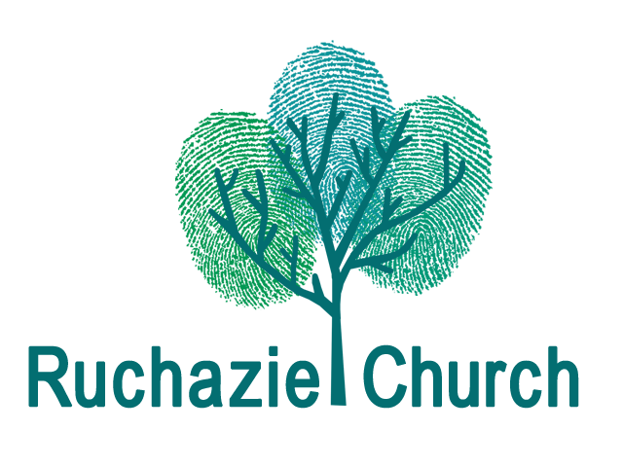
Our aim
We are looking for team players who can innovate, develop and lead our Youth and Creative Projects, which will pick up on themes of faith, identity and creativity, so that the church may become the Creative Hub of Ruchazie.
Ruchazie Church
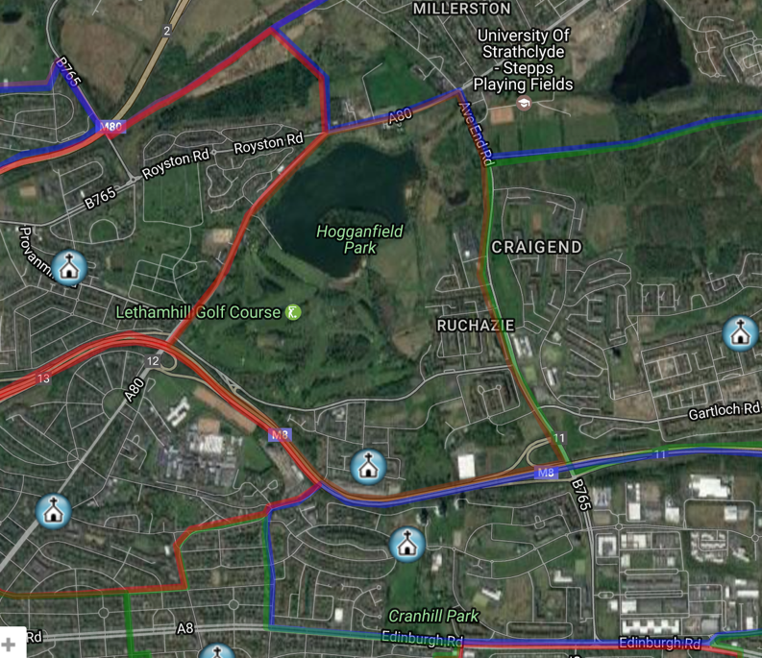
Ruchazie Church is a new church “replant” within the Church of Scotland. In the last 3 years we have re-established a worshipping community within the parish. This has built on the previous ongoing work within the community – children’s and youth work, work with older people, supporting vulnerable families, etc. There is now a core team of about a dozen leading this work with a pre-covid congregation of about 50 gathering weekly. As a church we are rooted in the evangelical tradition, looking actively for the work of the Holy Spirit in our lives, and our style is informal, friendly and welcoming.
Ruchazie is an area of significant deprivation. 41% of the children live in poverty. 67% of those attending our local secondary school have or had male relatives resident in Barlinnie Prison. 36% of the 16-19 year olds are not in any form of employment, education or training. There is no lack of issues, but that is not what we as a church are about.
We believe in this community. We believe that it is full of wonderful, dynamic, creative people made in the image of God. We believe that there is huge potential for this community to be transformed.
Previous Youth Work
Almost everything we had been doing has been closed down throughout the pandemic. Within the church there has been a mixture of afterschool and holiday time clubs and programmes. Some of this had been done in partnership with GK Experience, Bolt FM and Junction 12 (a local Christian youth project). The new Youth Worker would be expected to take a lead in helping rebuild a volunteer team and then relaunch the Youth Work programme.
Previous Creative Work
The creative work has also come to a halt during the pandemic. There had been a focus on music, video and online production. There is huge flexibility and openness about what a creative programme would look like and so the new Creative Worker would be expected to take a lead in helping rebuild a volunteer team and then develop a new creative programme.
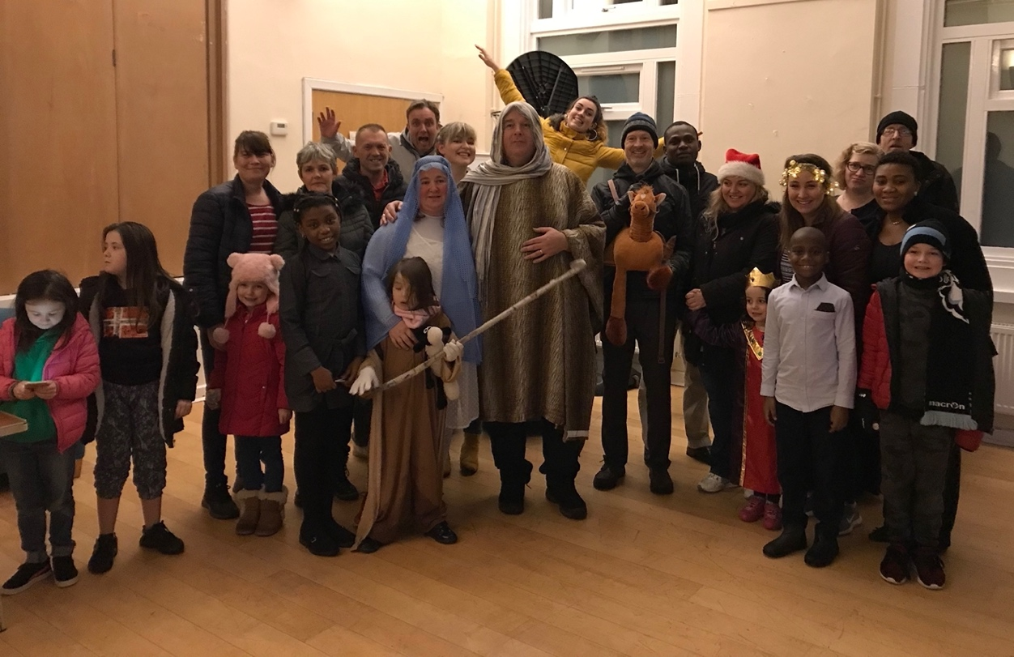

About the Youth Worker and Creative Worker
We are looking for team players who can innovate, develop and lead our Youth and Creative Projects - people who can build a strong team of volunteers to explore the themes of faith, identity and creativity. We want our building to become the creative hub of our community as a result of the work done. We want people who are passionate about faith and who believes that Jesus can change any person’s life.
We want someone who has experience and passion in using the Creative Arts to engage with a range of ages and stages across the community.
We also are looking for someone with a heart for young people, recognising the interaction of spiritual, emotional, physical and mental health, able to develop relationships and create programmes that address all of these.
It may be that these posts could be filled by the same person – we are open to that.

Youth Worker post | Creative worker post
To provide leadership and direction for the Youth Project with a primary focus on the 11-18 age range but working with others to enable transitions into and from this group.  To establish and develop a youth programme in partnership with other staff, wider team and other youthwork partners, which is the springboard for individual young people achieving their goals and discovering faith.  To support the participation and sense of belonging of young people in the Youth Ministry, as well as in the wider church family, and encourage their spiritual growth.  To maintain the safety and well-being of all involved in Youth Ministry in accordance with the Church of Scotland’s safeguarding policies and procedures.  To create opportunities for development and training of youth leaders including exploring the development of an internship programme.  To keep abreast of wider local, national and global developments in youth ministries. | To provide leadership and direction for the Creative Project, working with all ages and stages across the community.  To develop the community creative programmes and activities within the Church.  To work with other staff and wider team so that the church facility will become a hub for community creativity with music, art, drama and dance a regular feature of Ruchazie life.  To work with other staff and the wider team to develop and run an Arts Festival across the community.  To maintain the safety and well-being of all involved in Creative Ministry in accordance with the Church of Scotland’s safeguarding policies and procedures.  To create opportunities for development and training of volunteers including exploring the development of an internship programme.  To keep abreast of wider local, national and global developments in creative ministries.
For both posts
- To be a full member of the church staff team and leadership, including attending staff meetings and prayer times.
- To attend church services regularly at Ruchazie Church when not leading other activities.

Person Specification - Essential qualities / skills / experience
Strong Christian faith and calling*
- We are looking for someone with a growing personal faith in Jesus Christ, a good knowledge of the scriptures and an openness to the work of the Holy Spirit.
- A clear calling and commitment to this work and a passion for authentic Christian discipleship, within the vision and values of Ruchazie Church.
Qualifications and experience
- A nationally recognised Youth Ministry / Creative Ministry (as appropriate) qualification at degree level or equivalent; or significant experience of Youth / Creative Ministry leadership within church settings or comparable.
- A track record of building good working relationships with people from diverse backgrounds, including young people, their families and carers, and the wider church family and community
Knowledge and skills
- A clear and engaging communicator, both in writing and orally, having confidence to speak in front of large and small groups.
- A team player, with the ability to encourage and work collaboratively with others.
- An ability to think creatively and turn ideas into action to develop new areas of work.
- An up to date understanding of and commitment to working within Child Protection Policies and practice relating to the safeguarding of young people.
- A knowledge and awareness of current issues affecting young people and ability to work with these in engaging ways.

*There is a genuine occupational requirement that the person(s) appointed is a committed practising Christian in terms of the Equality Act 2010.
Additional Information for both posts
- These are half-time posts – each 18.75 hours per week.
- Salary is £25,000 per annum pro rata, that is £12,500.
- There is a 5% employers pension contribution available.
- These posts will be line-managed by the Congregational Development Worker.
- The nature of the work calls for a degree of flexibility, thus hours of work, which are as agreed with the line manager, may vary from day with a normal pattern being Sundays plus other days in Ruchazie each week.
- The posts are based at Ruchazie Parish Church, 4 Elibank Street, Glasgow, G33 3QN.
- A laptop will be provided.
- There are 5 weeks pro rata paid leave in each full holiday year which runs from 1 January to 31 December. Entitlement is based on full weeks worked. There are also 9 pro rata statutory holidays.
- Travel expenses by public transport or by use of own car at rates as agreed by the employer and reviewed annually.
- In view of the nature of the posts, the postholder will be required be a member of the Protecting Vulnerable Groups Scheme (PVG) (more info available at https://www.mygov.scot/pvg-scheme/)
- These posts have been funded by Go for It.

Closing Date: Tuesday 13th April at 9am
How to Apply
Applications should be sent by email to amcwilliam@churchofscotland.org.uk and must be received by 9am on the closing date.

Applications should comprise:
• A personal statement, outlining how your skills, experiences and personal qualities match the requirements of the role outlined in the job description.
• A full CV, including educational and professional qualifications alongside a full employment history showing positions held, responsibilities and relevant achievements.
• A personal information form – see attached. Please include names and email addresses of two referees, who will not be contacted until later in the process.

Applications without a CV, personal statement and personal information form will not be taken forward in the process. CV & personal statement should be a maximum of 2 sides of A4 each.

For more information on any of our roles, please contact amcwilliam@churchofscotland.org.uk (07702483503)

CONFIDENTIAL INFORMATION FOR EMPLOYMENT
Please complete Parts A & B: Print in black ink or type and
return it by no later than the deadline.
Late applications will not be accepted.

Part A

Personal
POST DETAILS
Post Title:

How did you hear of this post?

PERSONAL DETAILS
Name
Address
Postcode
Email address
Tel no

We are committed to being an Equal Opportunities Employer and do not discriminate in any way.

If you consider yourself to have a disability, are there any arrangements that we can make to assist/adapt, for you, if you are called to interview or if successfully employed? Please give details below.

REFERENCES
Name |  | Name
Occupation |  | Occupation
E-mail |  | Email
Organisation |  | Organisation
Address |  | Address
Post Code |  | Post Code
Tel No |  | Tel No
Relationship to applicant |  | Relationship to applicant
Referees will not be contacted prior to interview

DECLARATION
I confirm that all the information contained in Part A – Personal Information, Part B – Equal Opportunities Monitoring Information and Part C – Application for Employment is to the best of my knowledge correct and accurate. I understand that withholding or giving false information may be sufficient grounds for cancelling any agreements made.
I understand that the information provided in this application and monitoring form will be held and may be processed in keeping with the Data Protection Act 1998 for the purposes of employment and equal opportunities monitoring.

Data Protection Act 1998
Please read and sign below:
In applying for this post, I give my consent to Ruchazie Parish Church holding and processing data which is relevant to the recruitment process. This includes sensitive personal data which will be used for monitoring purposes.

Applicant’s Signature Date

Part B

Part B of the form will not form part of the selection process
Equal Opportunities Monitoring Information
The information you provide below will be treated as strictly confidential and will not form part of the selection process. We are committed to the principles of equal opportunities and aim to be an equal opportunities employer. To assist us in monitoring our progress in this, you are asked to complete the follow sections.
Please tick the relevant box in each of the sections below
Section 1: Gender Section 2: Age
Are You Are you
Female |  | Male |  |  |  | 16-19 |  | 20-24 |  | 25-39
Other |  | Prefer not to say |  |  |  | 40-59 |  | 60-64 |  | 65 +
 |  |  |  |  |  | Prefer not to say
Section 3: Ethnic Group (background or culture)
White Scottish |  | Other (South) Asian |  | Pakistani
Other White British |  | Chinese |  | Bangladeshi
White Irish |  | Caribbean |  | Mixed
Other White |  | African |  | Other
Indian |  | Black Scottish and other Black |  | Prefer not to say

Section 4: Disability – do you consider yourself to have;
No disability or impairment |  | A sensory impairment |  | A learning disability
A physical impairment |  | A mental health condition |  | Any other disability or impairment
Prefer not to say
Note: The disability categories used are broadly based on the definition of a disabled person in the Disability Discrimination Act 1995 as “someone with a physical or mental impairment which has a substantial or long-term effect upon his/her ability to carry out normal day to day activities.

Section 5: Religion:
Which of the following religions, religious denominations or bodies do you currently belong to?
None |  | Jewish |  | Other Christian
Church of Scotland |  | Muslim |  | Other Religion
Roman Catholic |  | Sikh |  | Buddhist
Hindu |  | Prefer not to say

Section 6: Sexual Orientation - Are you
Heterosexual |  | Gay |  | Transgender
Bisexual |  | Lesbian |  | Prefer not to say

