
Confidential
SU Scotland
70 Milton Street, Glasgow G4 0HR
Tel: 0141 352 7634 Fax: 0141 352 7600

STAFF APPLICATION FORM

Post Name: |  | Location:

Personal Details

Full name
Address (incl. postcode) |  | Tel (home)
Address (incl. postcode) |  | Tel (mobile)
Address (incl. postcode) |  | Tel (work)
Address (incl. postcode) |  | May we ring you at work, if discreet?
E-mail
Please note that if you supply an email address, this will be the means we use for all future correspondence.
Do you hold a full driving licence?
Please give details of any endorsements?
Are you a member (or have you recently applied for membership) of the Protecting Vulnerable Groups (PVG) Scheme?
If ‘yes’, is your PVG membership in respect of regulated work with Children, Adults or Both?
Please provide your PVG Membership Number:

Education

Please give details, with dates in chronological order, of secondary schools, colleges, universities or other places of education you have attended.

Dates | Place of Education | Qualifications attained
Do you hold any other qualifications not listed above? Please give details.

Work Experience

Please gives dates and details of professional, business or other working experience, or attach your CV.

I have attached my CV: Yes/No

Dates | Name & Address of Employer | Job Title | Outline of role, main tasks and responsibilities | Reason for leaving

Present salary: |  | Notice period:

Why have you applied for this position?

With reference to the person specification, why do you believe you are suitable for this position?

Outside Interests

What interests do you have outside church and your work?

Please give details of your Christian and secular reading over the past two years (papers; magazines; periodicals; books, including title and author)

Christian Experience

Of which section of the Christian Church are you a member?

What local place of worship do you normally attend & how long have you been going there?

Who is the minister or chief officer?

How and when did you become a Christian?

What Christian books, speakers or activities have been most influential in your spiritual life?

What positions, or other special involvement, have you had in your church?

What previous involvement, if any, have you had with Scripture Union?

What contact have you had with any other Christian organisations?

Please note there is a deliberate Page Break here.

Referees

Please give details of two people, apart from your employer, who are willing to act as your referees. We would prefer referees who have known you for at least the last two years. One should be your minister or church leader. The two referees should not have known you in the same context. If the post involves direct contact with children, it would be helpful if at least one reference came from someone who has seen you work with children or young people.

Name |  |  | Name
Status |  |  | Status
Address |  |  | Address
Postcode |  |  | Postcode
Tel. |  |  | Tel.
Email |  |  | Email

Employer’s Reference

When may we ask your employer for a reference?

To whom should we address the letter? | Name
To whom should we address the letter? | Company
To whom should we address the letter? | Address
To whom should we address the letter? | Postcode
To whom should we address the letter? | Tel.
 | Email

Please note that if you supply an email address for your referees, this will be the means we use to obtain references.

I hereby declare that the information given in this application form is correct to the best of my knowledge. I give permission for the form and references to be copied to those involved in the interviewing and selection process. I also give permission for those involved in the interviewing and selection process to review my volunteering history with SU Scotland.

I have read, understood and agree to abide by the SU Scotland Ethos Statement and Basis of Faith.

Signed: |  | Date:

If any member of the SU staff team/ Volunteer Leader at SU event is known to you, please give their name(s):

Please note that if you provide names of SU staff/ Volunteer Event Leaders who know you, you are giving permission for us to contact any of these people for reference information (unless you clearly indicate otherwise).

Confidential
SU Scotland
70 Milton Street, Glasgow G4 0HR
Tel: 0141 352 7634 Fax: 0141 352 7600

DOCTRINAL STATEMENT
Name:

State briefly what you regard as fundamental to your faith as a Christian.

What do you believe about the Bible, and its role in the life of the Christian individual and the church?

Please outline the importance of the death of Jesus Christ to you in your Christian beliefs.

Please outline your understanding of the Christian church.

How do you understand the work of the Holy Spirit?

What are your views on Christian involvement in society?

Signed:

Date:

PLEASE MAKE SURE THIS STATEMENT IS INCLUDED WITH YOUR APPLICATION FORM

ETHOS STATEMENT

Scripture Union Scotland, as part of an international family of SU movements, is fully committed to the Aims, Beliefs and Working Principles of SU International. Accordingly, this ethos statement should be read in conjunction with that document including the SU Basis of Faith (attached).

SU Scotland works to help all the children and young people of Scotland explore and respond to the significance of Jesus Christ for their lives and to encourage people to encounter God through the Bible and prayer. We hold this as our aim because we believe all human beings regardless of gender, sexuality, ethnicity, ability or disability, age, political or religious persuasion to be of equal worth before God and that all have the right to hear about his love for them as expressed in Jesus Christ. We also seek to encourage everyone to live in daily personal relationship with Jesus Christ, a relationship nurtured by both personal and corporate prayer and Bible engagement.

As an organisation our twin underlying values are dependence on God and deepening relationships. In these values we affirm our prayerful dependence on God and our commitment to change as we open ourselves regularly to Him through the Bible. Dependence on God is expressed through a commitment to corporate prayer and study of the Bible which are integral to the life of SU Scotland.

We believe the message of Jesus Christ should be evident in our relationships as well as in our teaching. Therefore the working environment of SU should be one in which relationships deepen and where care and support, encouragement, the development of gifts and the realising of potential are all fostered. A spirit of forgiveness should also characterize our relationships.

We believe following Jesus Christ demands a distinctive lifestyle which impacts upon
attitudes to money, possessions, time, work, leisure, social action and relationships. In relationships we strive to respect one another, to be accountable to one another and to seek unity without compromising individual integrity. The lifestyle we affirm is based on the teaching of the Bible and commends the Christian faith rather than seeking to bring it into disrepute.

We commit ourselves to the nurture, protection and safekeeping of all. In particular, we seek to ensure the physical, emotional and spiritual well-being and development of children and young people. Within this context we are committed to the protection of children and young people from all forms of abuse.
We aim to create a partnership amongst staff and between paid staff and volunteers in which there is mutual trust, respect and cooperation.

We define ourselves as working as part of the church but having a distinctive role. We will seek to work collaboratively with all Christian Churches and with other Christian organisations where there are areas of common interest and concern. We express this partnership practically by encouraging SU Scotland staff to be actively engaged in a local church.

Within SU Scotland, there are roles which have key spiritual elements to them. These roles can only be carried out by those who are committed to a living faith in Christ and therefore roles of this nature will be held by those who have such a faith.

We are committed to the pursuit of excellence with integrity in every area of work:

- As a mission organisation we will be relevant, practical and relational
- As a company we will be law-abiding, professional and efficient
- As an employer we will be fair, responsible and considerate

Adopted by the SU Scotland Board November 2007
SCRIPTURE UNION – BASIS OF FAITH

As the Scripture Union family throughout the world, we accept and proclaim the historic truths of the Christian faith including the following:

1 God and the human race: We hold that the Lord our God is one: Father, Son and Holy Spirit, and that He fulfils His sovereign purposes – in creation, revelation, redemption, judgement, and the coming of His Kingdom – by calling out from the world a people, united to himself and to each other in love. We acknowledge that though God made us in His own likeness and image, conferring on us dignity and worth and enabling us to respond to Himself; we are now members of a fallen race; we have sinned and come short of His glory. We believe that the Father has shown us His holy love in giving Jesus Christ, His only Son, for us, while through our sinfulness and guilt, we were subject to His wrath and condemnation; and has shown His grace by putting sinners right with Himself when they place their trust in His Son. We confess Jesus Christ as Lord and God; as truly human, born of the virgin Mary; as Servant, sinless, full of grace and truth; as only Mediator and Saviour, dying on the cross in our place, representing us to God, redeeming us from the grip, guilt and punishment of sin; as Victor over Satan and all his forces, rising from death with a glorious body, being taken up to be with His Father, one day returning personally in glory and judgement to establish His Kingdom. We believe in the Holy Spirit who convicts the world of guilt in regard to sin, righteousness and judgement; who makes the death of Christ effective to sinners, declaring that they must turn to Christ in repentance, and directing their trust towards the Lord Jesus Christ; who through the new birth makes us partake in the life of the risen Christ, and who is present within all believers, illuminating their minds to grasp the truth of Scripture, producing in them His fruit, granting to them His gifts, and empowering them for service in the world.

2 The Scriptures: We believe that the Old and New Testament Scriptures are God-breathed, since their writers spoke from God as they were moved by the Holy Spirit; hence are fully trustworthy in all that they affirm, and are our highest authority for faith and life.

3 The Church and its Mission: We recognise the Church as the body of Christ, held together and growing up in Him; both as a total fellowship throughout the world, and as the local congregation in which all believers gather. We acknowledge the commission of Christ to proclaim the Good News to all people, making them disciples, and teaching them to obey Him; and we acknowledge the command to love our neighbours, resulting in service to the church and society, in seeking reconciliation for all with God and their fellows, in proclaiming liberty from every kind of oppression; and in spreading Christ’s justice in an unjust world … until He comes again.

Verification of Eligibility to work in the United Kingdom

Validity of Documents

The Home Office requires that employers check the certificates / in-date passports/ immigration or visa documents of their prospective employees. It is crucial that the correct evidence is provided which continues to allow you to work by virtue of status (i.e. your stay is indefinite) or date (the end of your permitted stay has not expired).

If you have indefinite eligibility to work in the UK you must be able to provide all the documents listed in one of the boxes in List A below.

If you have time-limited eligibility to work in the UK you must be able to provide all the documents listed in one of the boxes in List B below

Photocopies of your eligibility to work in the UK is required as part of your application for employment with Scripture Union Scotland.

Please note you will be required to bring the original documents with you if you are invited to interview.


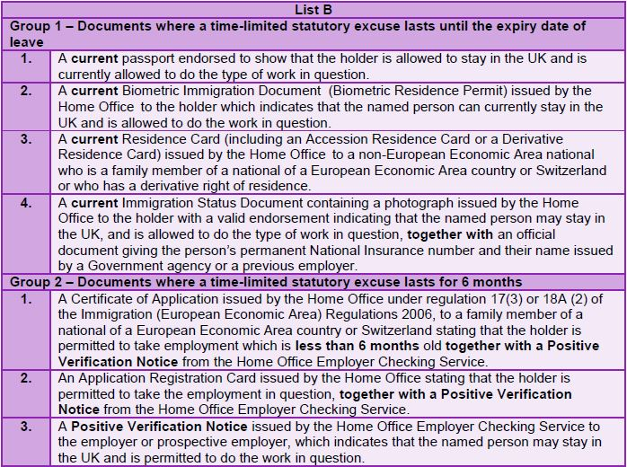

August 2014

