
Confidential
JUNCTION 12
Office address: 176 Smithycroft Road, Riddrie, G33 2RF
Tel: 0141 770 9028 Email: info@junction12.org.uk

STAFF APPLICATION FORM

Post applied for:

Personal details

Full name
Address (incl. postcode) |  |  | Tel (Home)
Address (incl. postcode) |  |  | Tel (Mobile)
E-mail
Do you hold a full driving licence?
Please list any current endorsements?

Education

Please give details, with dates in chronological order, of secondary schools, colleges, universities or other places of education that you have attended.

Dates | Place of education
What tertiary level certificates, diplomas, degrees or other qualifications do you hold? Please give details.

Work experience

Please gives dates and details of your professional, business or other working experience. Alternatively, you can attach your CV, in which case mark the box below accordingly.

I have attached my CV:

Dates | Name & Address of Employer | Job Title | Outline of role, main tasks and responsibilities | Reason for leaving

Present salary: |  | Notice period:

Suitability for the post

Why have you applied for this position?

Why do you believe you are suitable for it?

What qualities and relevant experience would you bring to this post?

Outside interests

What are your interests and hobbies? How do you like to spend your spare time?

Christian experience

To which local church do you belong?

Describe your journey to Christian faith.

What do you believe about the Bible? What is its relevance to your life?

Describe your involvement with Church or other Christian organisations.

Additional information

Please use this section to set out any other information that you feel would be relevant to your application.

Please note there is a deliberate Page Break here.

Referees

Please give details of two people, apart from your employer, who are willing to act as your referees. We would prefer referees who have known you for at least the last two years. One should be your minister or church leader. The two referees should not have known you in the same context. If the post involves direct contact with children, it would be helpful if at least one reference came from someone who has seen you work with children or young people.

NB: Present Office Bearers or employees of Junction 12 are unable to act as Referees.

Name |  |  | Name
Status |  |  | Status
Address |  |  | Address
Postcode |  |  | Postcode
Tel. |  |  | Tel.
Email |  |  | Email

Employer’s reference

When may we ask your employer for a reference?

To whom should we address the letter? | Name
To whom should we address the letter? | Company
To whom should we address the letter? | Address
To whom should we address the letter? | Postcode
To whom should we address the letter? | Tel.
 | Email

Please note that if you supply an email address for your referees, this will be the medium which we will use.

I hereby declare that the information given in this application form is correct to the best of my knowledge. I give permission for the form and references to be copied to those involved in the interviewing and selection process. Junction 12 runs residential events in partnership with Scripture Union Scotland therefore I give permission for those involved in the interviewing and selection process to review my volunteering history with Junction 12 and Scripture Union Scotland.

I have read, understood and agree to abide by the Junction 12 Ethos Statement.

Signed: |  | Date:

If any member of the Junction 12 staff team/ Volunteer Leader at Junction 12 event is known to you, please give their name(s):

Please note that if you provide names of Junction 12 staff/ Volunteer Event Leaders who know you, you are giving permission for us to contact any of these people for reference information (unless you clearly indicate otherwise).

If you are posting this application form please mark the envelope ‘Confidential’ and address it to:
Nicola Affleck, SU Scotland, 70 Milton Street, Glasgow G4 0HR

If you are emailing this application form please send it to:
vacancies@suscotland.org.uk

DOCTRINAL STATEMENT
If the space is insufficient for your answer to any question, please attach further sheets.
Name:

State briefly what you regard as fundamental to your faith as a Christian.

What do you believe about the Bible, and its role in the life of the Christian individual and the church?

Please outline the importance of the death of Jesus Christ to you in your Christian beliefs.

Please outline your understanding of the Christian church.

How do you understand the work of the Holy Spirit?

What are your views on Christian involvement in society?

Signed: Date:

PLEASE MAKE SURE THIS STATEMENT IS ATTACHED WITH THE APPLICATION FORM.
JUNCTION 12
ETHOS STATEMENT

Junction 12 (J12) works to support young people of senior primary and secondary school age, irrespective of their gender, sexuality, ethnicity, disability, political or religious persuasion, in the Cranhill, Carntyne and Riddrie areas of Glasgow. J12 will at all times seek to do this within a framework of the Christian faith, in particular the following of Christ’s teaching and his example of unconditional love and sacrificial service to others.

As an organisation we affirm our prayerful dependence on God and our commitment to change as we open ourselves regularly to Him through the Bible. We are committed to the pursuit of excellence with integrity in every area of work:

- as an organisation we will be relevant, practical and relational;
- as a charity we will be law-abiding, professional and efficient;
- as an employer we will be fair, responsible and considerate.

We believe the Christian message should be evident in our relationships and in our teaching where this is appropriate. The working environment of J12 should be one that fosters care and support, encouragement, the development of gifts and the realising of potential. A spirit of forgiveness, reflecting the recognition that as people we often fall short of the ideal, should also characterise us. We believe that grace and forgiveness are always available to those who repent.

We believe that being a Christian demands a distinctive lifestyle which impacts upon attitudes to money, possessions, time, work, leisure, social action and relationships. In relationships we strive to respect one another, to be accountable to one another and to seek unity without compromising individual integrity and biblical principles.

We believe that, following the example of Jesus Christ, incarnational ministry is the most effective way to reach out to children, young people and families. We therefore encourage staff and volunteers to establish and develop long term relationships and to show Christ’s love and compassion in all areas.

We commit ourselves to the nurture, protection and safekeeping of all. In particular, we seek to ensure the physical, emotional and spiritual well-being and development of children and young people. Within this context we are committed to the protection of children and young people from all forms of abuse.

We aim to create a partnership amongst staff and between paid staff and volunteers in which there is mutual trust, respect and cooperation.

We will seek to work collaboratively with Christian Churches and with other organisations where there are areas of common concern.

March 2011
Equal Opportunities Monitoring Form
It is the policy of Junction 12 to practise a fair and non-discriminatory recruitment process.

All applicants will be considered on the basis of their suitability for the post. This principle will apply to all internal and external recruitment.

Junction 12 is committed to upholding equality of opportunity in employment. No job applicant will be unfairly discriminated against because of their race, ethnic or national origin, sex, disability, age or marital status. Junction 12 reserves the right to discriminate in favour of applicants on the basis of religion for posts for which a Genuine Occupational Requirement (GOR) has been identified.

In order to monitor our provision of equality of opportunity and comply with discrimination legislation, please complete the following questionnaire:

This information will be treated in strict confidence and used for statistical purposes only. The sheet will be separated from your application form before short-listing.

Post applying for:

Location of post:

Age Range: under 25 26 – 35 36 – 45 46 – 55 56+

Gender: Male Female

Marital Status: Single Married Other

Country of Birth: Nationality:

Ethnic Origin: (These monitoring categories are as advised by the Commission for Racial Equality)

Do you consider yourself to be:

Black-African Black-Caribbean Black-British Black-other, please specify:

Indian Chinese Pakistani White

Irish Bangladeshi Other, please specify:

1st language:

Disability: The Disability Discrimination Act 1995 defines disability as: ‘A physical or mental impairment which has a substantial and long-term adverse effect on your ability to carry out normal day-to-day activities’

Do you consider yourself to have a disability as defined? Yes No

If so, what practical adjustments may be required to enable us to appropriately assess you if short listed?

What practical adjustments may be required to enable you to carry out the job?

Source of Introduction (please specify how you first found out about this job):
SU Website J12 Website Newsletter Personal Introduction
HR use:
Processed
Youthwork/Premier Magazine/Website Goodmoves/SCVO Website/ Third force news Other (name)
Criminal Convictions and Disclosure

Name:

Post applying for:

Location of post:

Have you been charged with, or convicted of any criminal offence (excluding minor traffic offences), or do you have any cases pending?

Yes No

Are you listed on the Disqualified from Working with Children List, List 99 or subject to a Disqualification Order within the meaning of the Criminal Justice and Court Service Act 2000?

Yes No

If you have ticked ‘yes’ and you have been short-listed for interview, we will send a declaration form to be completed together with a separate envelope marked ‘CONFIDENTIAL’ for its return to the HR Advisor.

Signed: Date:

(NB: Working for Junction 12 with children and young people means that the provisions of the Rehabilitation of Offenders Act 1974 do not apply. Consequently you are not entitled to withhold information on a criminal conviction on the grounds that it is ‘spent’ or forgotten under the provisions of the above Act.)

This post requires you to complete a PVG Application/Update form relating to criminal offences under the provisions of the Rehabilitation of Offenders Act 1974 an application will be sent to you by return.

(NB: Junction 12 has a policy on the recruitment of ex-offenders; a copy of this policy is available on request.)

Verification of Eligibility to work in the United Kingdom

Validity of Documents

The Home Office requires that employers check the certificates / in-date passports/ immigration or visa documents of their prospective employees. It is crucial that the correct evidence is provided which continues to allow you to work by virtue of status (i.e. your stay is indefinite) or date (the end of your permitted stay has not expired).

If you have indefinite eligibility to work in the UK you must be able to provide all the documents listed in one of the boxes in List A below.

If you have time-limited eligibility to work in the UK you must be able to provide all the documents listed in one of the boxes in List B below

Photocopies of your eligibility to work in the UK is required as part of your application for employment with Scripture Union Scotland.

Please note you will be required to bring the original documents with you if you are invited to interview.

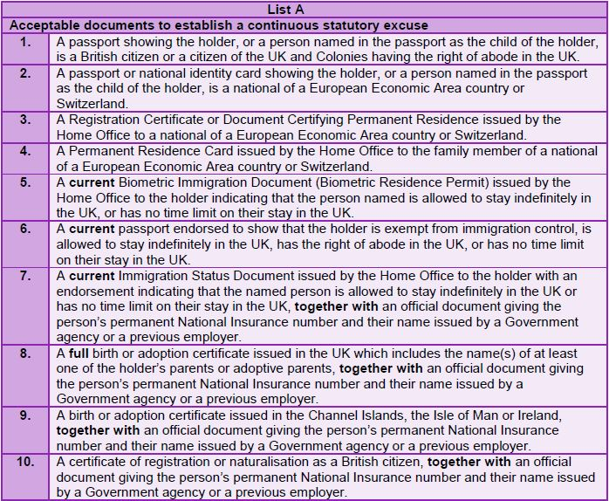
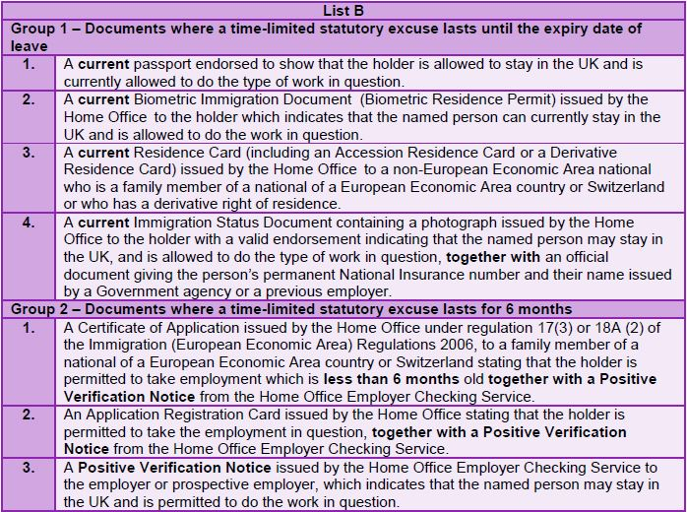

August 2014

